South Oxfordshire Sustainability
Come and hear the views of leaders of three of Oxfordshire's key sustainability organisations

*Barbara Hammond

(CE Low Carbon Hub)

*Ingo Shuder
(CE Wild Oxfordshire)

* Peter Thompson (Chair Oxford Civic Society)

*****************
Can we plan for 15000 new houses in S. Oxon & still cut greenhouse gas emissions & preserve our rural character & bio-diversity?
***************
SOS (South Oxfordshire Sustainability) is an alliance of community action groups working to persuade our Councils to put sustainable development at the heart of their policies.
Public Meeting
7.30 ON APRIL 24
WALLINGFORD TOWN HALL
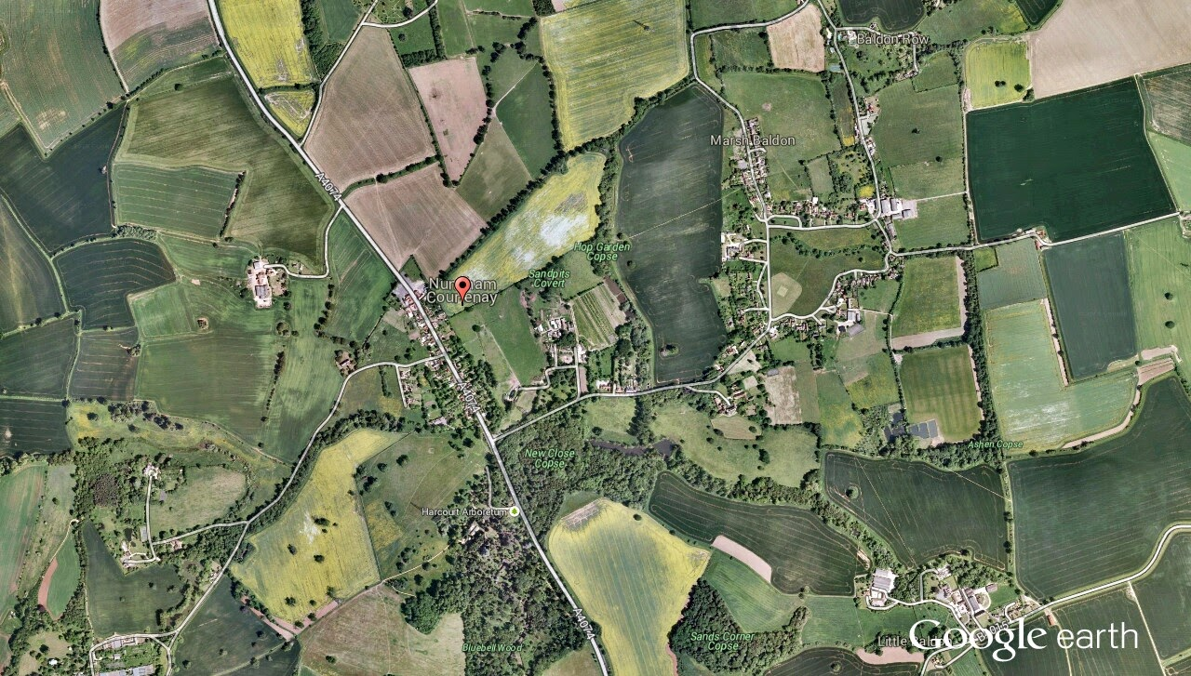
CAN WE DO IT
BETTER?
IN
OXFORDSHIRE
PLANNING

